***College of Information Technology***

***University of Da Nang***

***Project in Java programming 2016-2017***

***Project’s name : Simulate ATM system***

***Students: Thân Quốc Chung & Phạm Sỹ Cường***

1. **Introduction**

* **The reason for choosing the topic** :Information technology (IT) is playing an increasingly important role in our lives. The application of IT in the areas of life helps work to be carried out more quickly and efficiently. There are many new developments in parallel with the development of IT, one of which is the ATM system, the service direction brings great efficiency and economic. We chose the ATM program to learn more about java in object-oriented programming, from which to write a specific test application that underlies knowledge and navigation. Plans to build and develop similar applications in the future to serve human life.
* **Practical application** : This helps us to better understand how the ATM system works, understand its importance, and thereby apply it in practice.
* **Features** : - Withdrawal
* Fund transfers
* Change PIN
* Check account

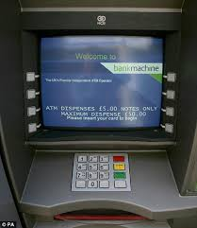

1. **Analysising system**

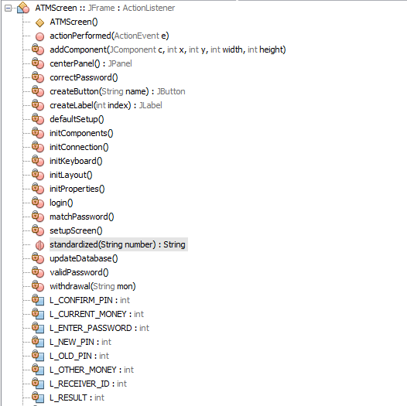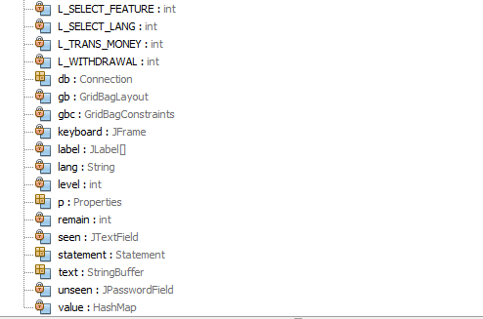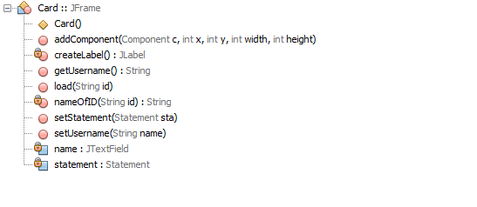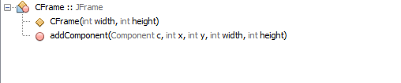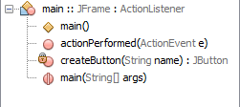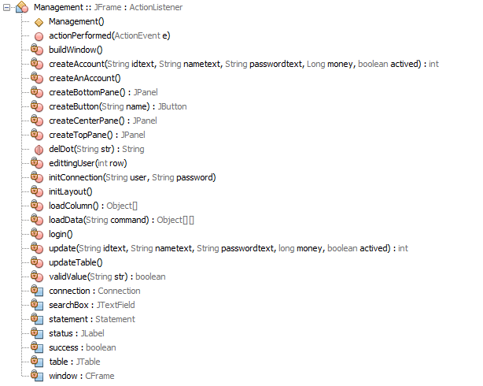

1. **Designing system**

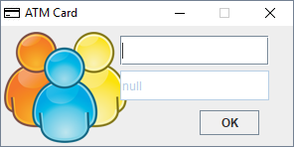

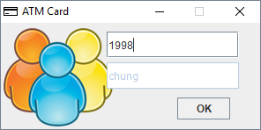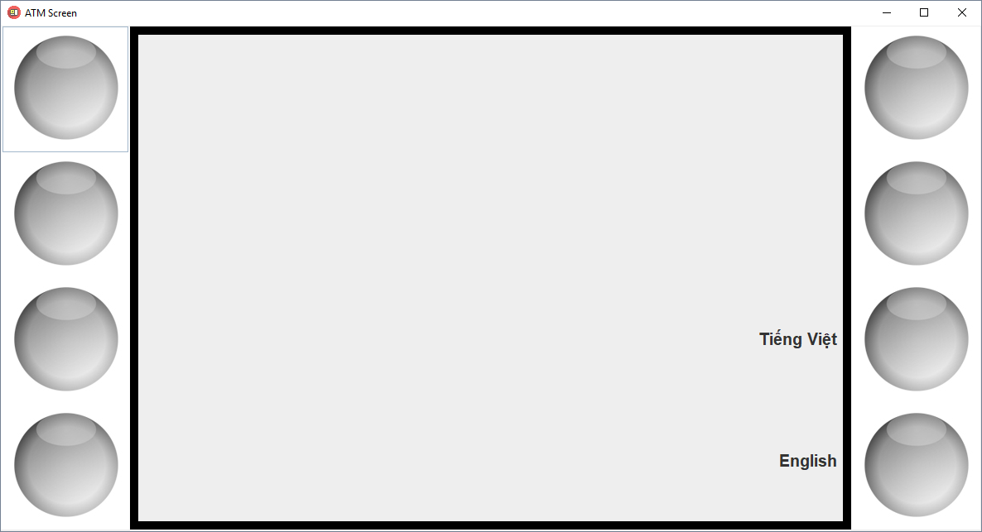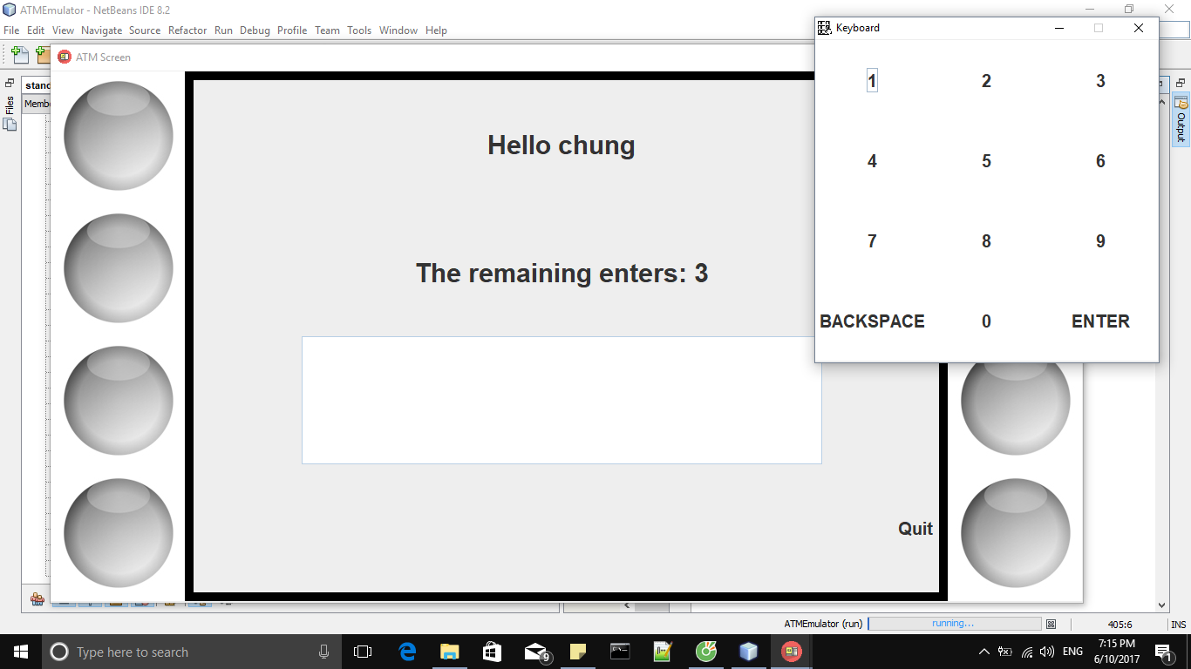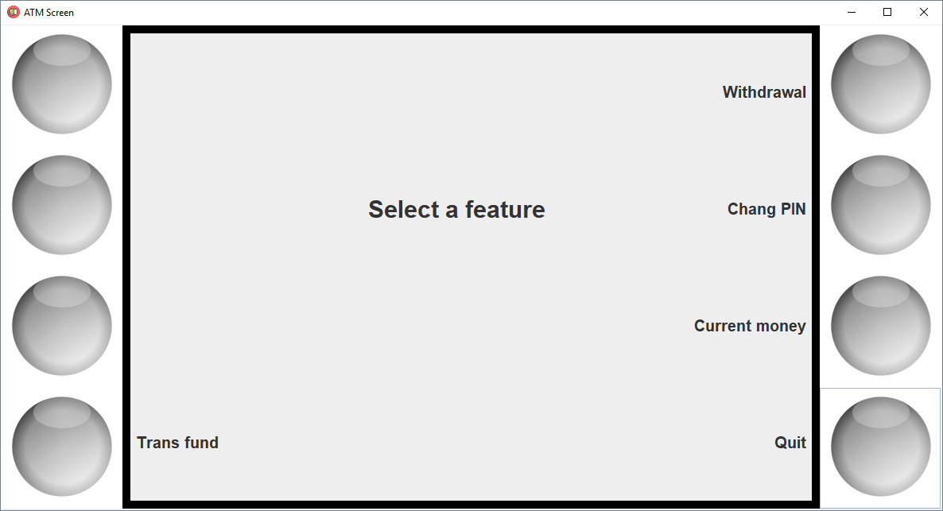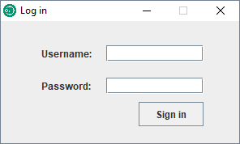

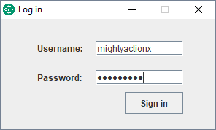

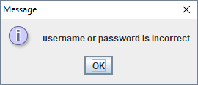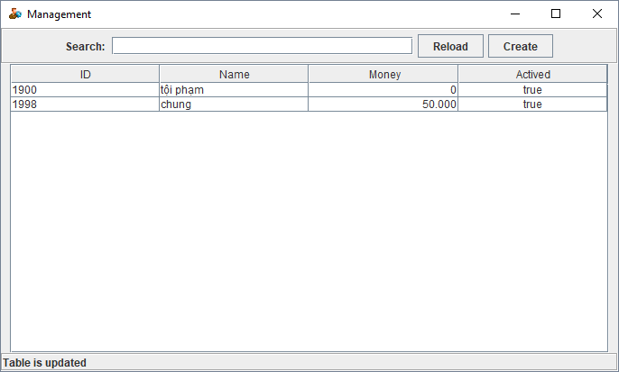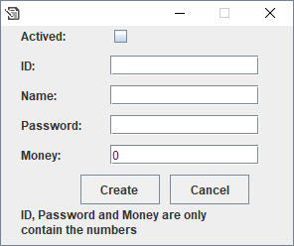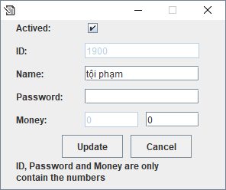

1. **Conclude**

**- Achieved :**

* Successfully built ATM model by Java programming language.
* Understand how the application works

**- Not achieved :**

* There are some features missing from the ATM system.
* The interface is not beautiful.

**-Development plan :**

* It is possible to build a more convenient system derived from the ATM system
* Java application in many areas actually improve life